**Introduction to Decision tree**

An Intrusion detection tree is a framework that screens organization to check unsafe exercises in the organization and reports occasions that doesn't meet the security measures to the organization director. IDSs are sorted as Signature based and Anomaly based. Mark or Misuse based IDS utilizes different strategies to find the similitude among framework conduct and recently realized assaults put away in the mark data set. Irregularity based IDS identifies exercises in an organization which digresses from typical ways of behaving put away in framework profiles data set. There are different classifiers that are appropriate to abuse based recognition.

A Decision Tree is a tree-like chart involving inside center points which address a test on a quality and branches which mean the consequence of the test and leaf center points which suggest a class name. The portrayal rules are outlined by the way browsed the root center to the leaf. To segment every data, first the root center is picked as it is the most prominent property to segregate the data. The tree is worked by perceiving credits and their connected characteristics which will be used to explore the data at each temporary center point of the tree. After the tree is outlined, it can prefigure as of late coming data by crossing, starting from a root center to the leaf center visiting all of the inward center points in the manner depending on the test conditions of the characteristics at each node.

**Decision Tree Algorithm**

This algorithm is dependent on C4.5 decision. This algorithm consists of 8 steps:

1. In the event that all the given preparation models have a place with a similar class, a leaf hub is made for the choice tree by picking that class

2. calculate the gain ratio for every feature by splitting the information. It is calculated by using

Where ‘a’ is the feature, IG is information gain.

3. Information gain is calculated using the formula



Where S is the set of possible examples for the attribute ‘a’.

4. Entropy is calculated by



Where L is the set of classes

5. For the split value for an attribute which can be calculated using

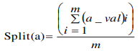

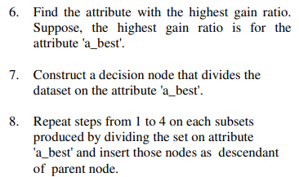

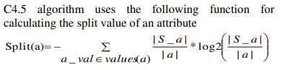

**Implementation**

The investigations were done for execution relationship of different tree-based classifiers and the DTS computation. The examination is finished considering different limits, for instance, how long the classifier expects to foster the model, false certain rate, certifiable positive rate, and precision. True Positive (TP) addresses the models that are precisely expected as ought normal. Ture Negative (TN) shows the events which are precisely expected as an attack. False Positive (FP) perceives the models which are expected as attack while they are not. False Negative (FN) addresses the cases which are prefigured as commonplace while they are attack truth be told. Accuracy can be described as the number of right assumptions. Which is computed using

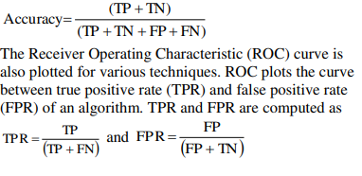

Decision tree assists the association with going to settle on a decision about the coming traffic, i.e., whether or not the oncoming data is malicious by giving a model that confines malignant and non-pernicious traffic. By changed the split worth calculation by taking the ordinary of the huge number of values in the space of a characteristic. The estimation gives uniform weightage to all of the characteristics nearby. It grants taking less attributes and gives good accuracy in reasonable record of time. From the results of the tests, it is contemplated that the proposed estimation for signature-based interference distinguishing proof is more useful concerning finding attacks in the association with less number of components and it requires less venture to foster the model. It is in like manner contemplated that the capability depends upon the size of the educational assortment and the number of features used to foster the decision tree. The recipe used in DTS to learn gain extent can moreover be used in property assurance for feature decline. Our future degree of work is to chip away at the split worth by using thoughts, for instance, numerical mean which similarly gives uniform weightage to the area values.

References

M. Kumar, M. Hanumanthappa and T. V. S. Kumar, "Intrusion Detection System using decision tree algorithm," 2012 IEEE 14th International Conference on Communication Technology, 2012, pp. 629-634, doi: 10.1109/ICCT.2012.6511281.

Ashwini Pathak , Sakshi Pathak, 2020, Study on Decision Tree and KNN Algorithm for Intrusion Detection System, INTERNATIONAL JOURNAL OF ENGINEERING RESEARCH & TECHNOLOGY (IJERT) Volume 09, Issue 05 (May 2020),

Rai, Kajal & Devi, Mandalika & Guleria, Ajay. (2016). Decision Tree Based Algorithm for Intrusion Detection. International Journal of Advanced Networking and Applications. 7. 2828-2834.